

Ellulcian CRM Recruit Upgrade Branding Workbook

Last Modified: 5/1/2018

Table of Contents

What Ellucian Provides 3

Logo 3

Favicon 3

Color Palette 4

Background Image 4

Login Page 5

*Welcome Page (optional) 5

Welcome Text 6

Create an Account jump link 6

Forgotten Password 6

Footer definition 6

My Account page 8

Introductory Text 8

Default Spotlight 9

Contact Us 10

Facebook Login Button 11

# What Ellucian Provides

Ellucian will provide you with a single branded template, preconfigured to render appropriately in Internet Explorer, Firefox and Chrome browsers. **Note, due to the constant changes and updates delivered by the various browser vendors, the rendering of the pages may vary slightly in the browser.** All branded templates will be tested and delivered against the latest supported release of the supported browsers mentioned. Any incompatibilities with end of life browsers or beta release browsers will not be supported.

For a list of compatible web browsers, please click [here](https://technet.microsoft.com/en-us/library/dn531055.aspx).

Items marked with a **Red** (*) in are required.

**Please deliver all Images and Graphics in .jpg, .png, or .ico (for favicon images) formats in high resolution format to allow scaling\resizing if needed.**

# Logo

|  |  |
| --- | --- |
|  | Your institution’s logo provided in either **.jpg or .png format**, **no larger than 375px wide 80px high** |

***Please provide this image by removing the image above and inserting your image here. Note that the above image has a transparent background and is placed over a blue background.***

# Favicon

Please provide a favicon image that is 16 by 16 pixels.



***Please provide this image by removing the image above and inserting your image here.***

# Color Palette

|  |  |
| --- | --- |
| Core Blue - #041E42  Deep Blue - #151F6D  Bright Blue - #005c97  Black - #000  White - #FFF  Red - #B10E1E – used only for form validation etc.  Grey - #595959  Success Green - #006726 | Your institution’s color palette provided in **HTML hex code format**, used to coordinate the page template to the overall marketing/branding of your institution. Please note there is no set number of colors – Primary and Secondary are needed. We will also utilize your existing site for complementary colors if needed. |

|  |
| --- |
| Primary Color(s):  Core Blue - #041E42  Deep Blue - #151F6D  Bright Blue - #005c97  Success Green - #006726  Black - #000  White - #FFF |

|  |
| --- |
| Secondary Color(s):  Grey - #595959 |

# Background Image

If you would like to use an image for the background of the Constituent Experience please load the image below. The image should be at least **1024 pixels wide by 724 pixels tall**. A color may be used instead of a background image if desired

No background please, just off-white #F4F4F4.

*Note that when the site is viewed at resolutions under 768 pixels wide, no background image will be displayed.

# Login Page

On the Login Page the user can complete a few tasks, with ultimately the goal of getting them to create an account, or to log in if account is already created.

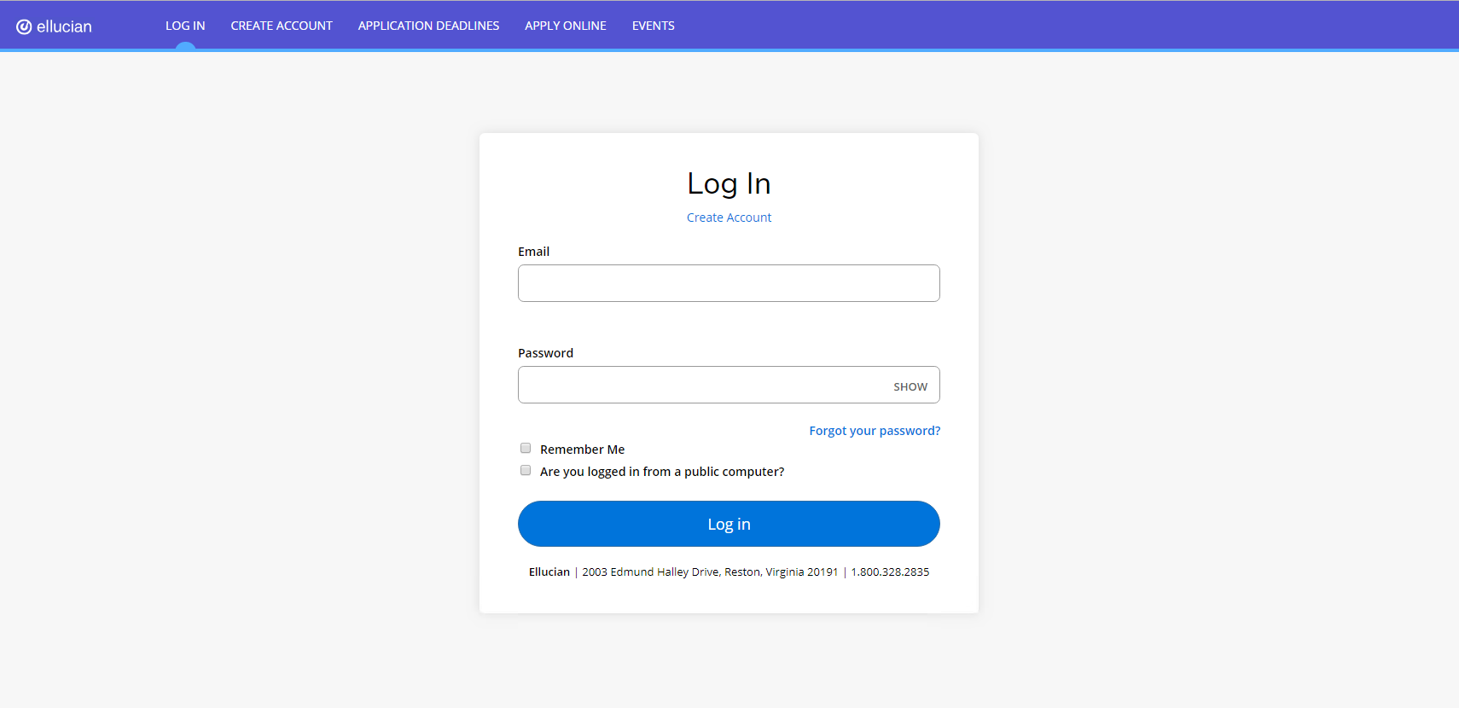

# *Welcome Page (optional)

Would you like to use the Welcome Page option? Enabling the Welcome Page will add a Welcome Message, Create Account Link and helper text, and Forgotten Password link and helper text above the login form. Yes No

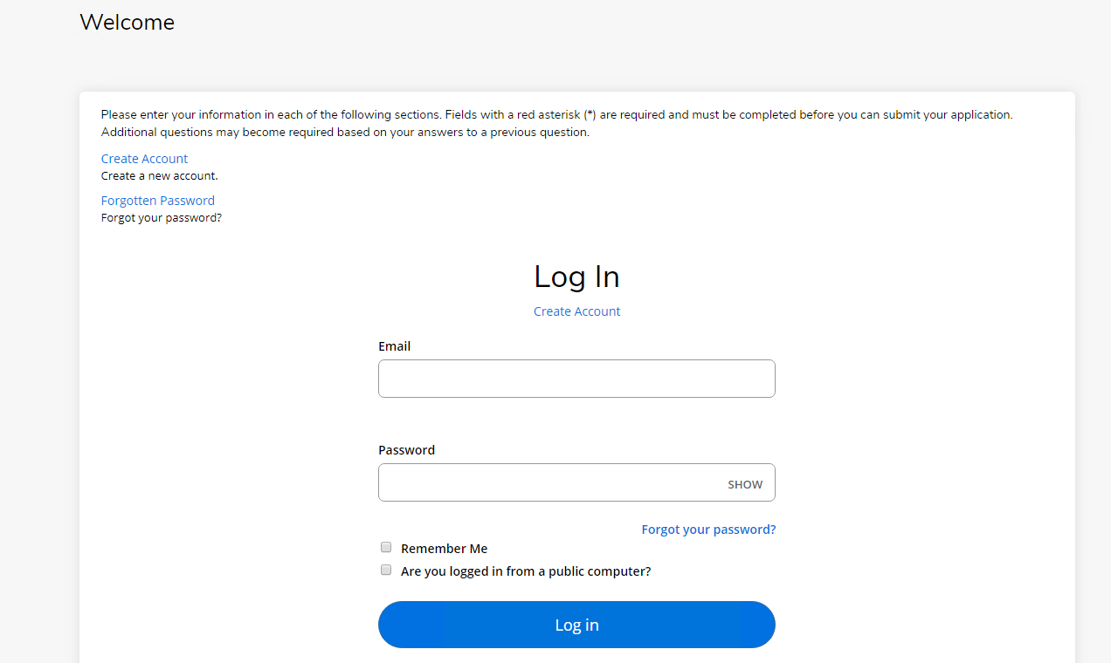

# Welcome Text

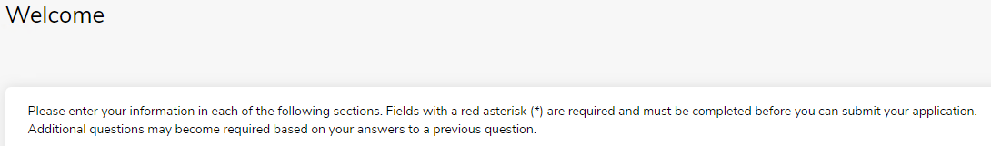

|  |
| --- |
| *Please insert desired copy here* |

# Create an Account jump link



|  |
| --- |
| *Please insert desired copy here* |

# Forgotten Password



|  |
| --- |
| *Please insert desired copy here* |

# Footer definition



|  |
| --- |
| *Please insert desired copy here* |

# My Account page

The “My Account” page is a landing page for the logged in student, where common tasks can be found. Some content will need to be provided so it is included upon delivery.

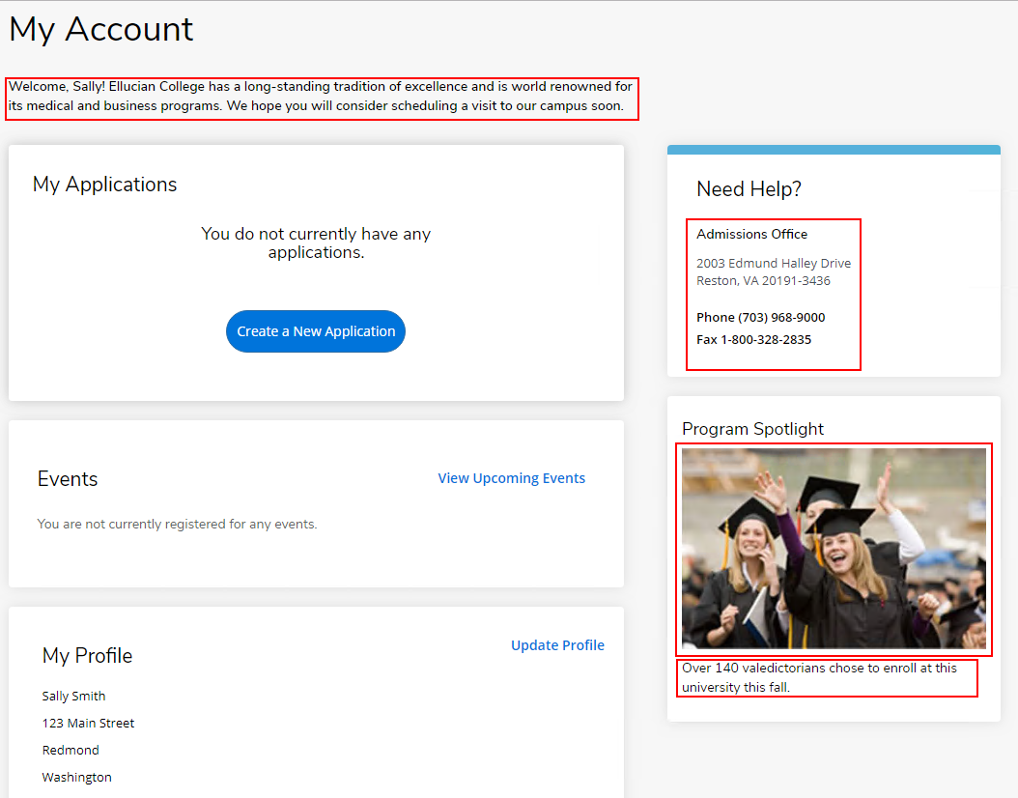

# Introductory Text



|  |
| --- |
| *Please insert desired copy here* |

# Default Spotlight

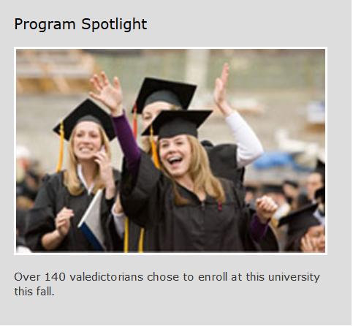

*The Default Spotlight will appear if Academic Program Descriptions and URLs are not configured.  
Please supply the image and text (Image should be 275px wide)*

|  |
| --- |
| *Please insert desired copy here* |

# Contact Us

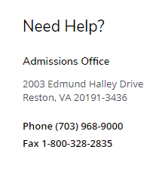

|  |
| --- |
| *Please insert desired copy here* |

# Facebook Login Button

Please define if you would like to have the Unified Facebook login button turned on or off. This will allow students to login using their Facebook account credentials.

Would you like to use the Facebook button?

Yes

No

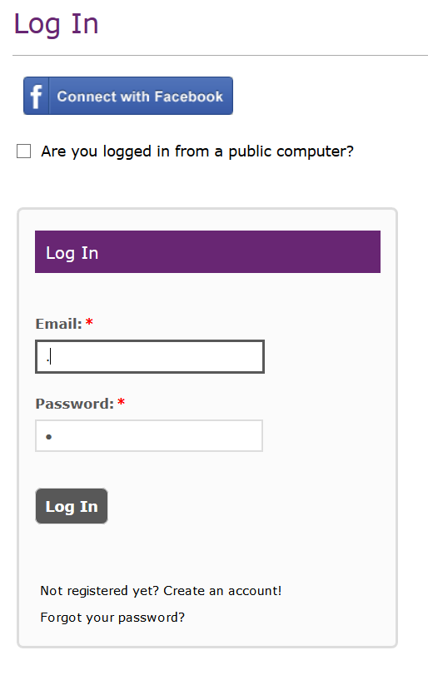

*If you have chosen to use the Facebook button, there are additional steps your institution would have to take to work properly. For more information please contact the technical consultant that will be hosting this engagement.*